Stored Procedure Level 2 – Hands on Document

1. Consider the tables Employee(Eno,Ename, Hire_date, salary). Write a stored procedure that fetches the Records, of those Employees who have completed 10 years in the organization, into a cursor. The SP should use a loop to display all the records from the Cursor
2. Write an SP that takes the employee code as parameter and computes the Loss Of Pay. The S P should insert the empcode and LOP amount into LOP Table. The SP Uses information from the following table: LEAVE_DET(EmpCode, DateOfLeave, TypeOfLeave). Every employee is allowed only 20 days of leave in a year. This table contains the information on the leave availed by the employee throughout the current year. Your SP should calculate the total leave availed by the employee and check if it is less than or equal to 20. If not LOP is computer as no_of_days_excess_leave * Per_Day_Basic. Get the details of the PerDayBasic from the Basic Salary Column in the Employee table.
3. Write an SP to compute the Total Amount of the Item. When the Quantity is Greater than 10 and less than 50 then 20% discount is provided. When the Quantity is between 100 and 500 then 50% discount is provided otherwise provide 5% discount for all the items.

Hint : Use Cursor to update the date in the Discount Table(Discountid,Itemno,Amount)

1. Write a stored procedure that process the records from the LEAVE table with the following structure . LEAVE (Ecode , Date_Of_leave , Reason). This stored procedure should consolidate the total number of leave availed by each employee , monthwise and insert the same into another table LEAVE_DETAILS(Eno, Month, Year, Days) . USE CURSOR for the same
2. Write an SP to compute the Total Amount of the Item. When the Quantity is Greater than 10 and less than 50 then 20% discount is provided. When the Quantity is between 100 and 500 then 50% discount is provided otherwise provide 5% discount for all the items. Hint : Use Cursor to update the date in the Discount Table(Discountid,Itemno,Amount)
3. Consider the following tables with the data in them

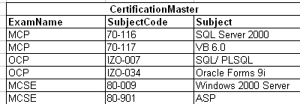

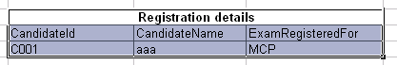

NOTE:- These table only contain sample data. Assume that there may be other records also.

The table Certification Master gives the details about the different certification programs.

The table Registration details , gives informationabout Candidates who have registered for

various exams.When a candidate Registers for a particular Exam , such as MCP, should have cleared

all the subjects in that Exam , only then he is eligible to get the certification.The Exam details table

contains information about the marks scored by the candidate in various exams.

You are required to Write an SP that processes data from these table and identifies the name of all those candidates who are eligible to get the certification in the exams for which they have registered. The candidate name and the Certification exam name should be entered in Another table RESULTS(CandidateName, ExamCertified).

1. Consider the following tables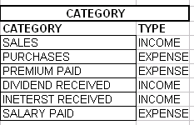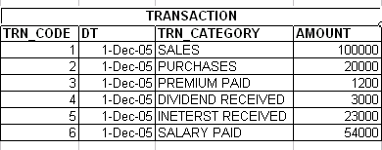

The table Category contains the details regarding the Transaction categories and also whether that transaction represents income or expenditure. The transaction table contains the details of the actual transactions performed . Using the table , the SP should identify the Net Profit . (Total Income- Total Expenditure) and display the same.

1. Consider a table Feedback(Subject, Student_No, Quality_Of_Training, Examples_Used, Confidence_Of_Faculty). This table records the feedback of each and every student in for a specific training program. The columns Quality_Of_Training, Examples_Used and

Confidence_Of_Faculty would have the following values… EXCELLENT, VERY GOOD, GOOD, SATISFACTORY ,POOR Every student who attended the training would have given his / her comments (EXCELLENT, VERY GOOD, GOOD, SATISFACTORY

,POOR) to every point (Quality_Of_Training, Examples_Used and Confidence_Of_Faculty). You are required to Write an SP that would calculate the average Feedback percentage. Average is calculated as follows using points as

EXCELLENT→ 5 points, VERY GOOD → 4 points, GOOD → 3 points, SATISFACTORY 2 points , POOR 1 point

Compute the average for every column individually and find the grand average and display the result